NAME: DHIVAHAR. P
DEPARTMENT: B.E BIOMEDICAL ENGINEERING
COLLEGE: 8151- DHANALAKSHMI SRINIVASAN INSTITUTE OF TECHNOLOGY, SAMAYAPURAM, TRICHY
NAANMUDHALVAN COURSE: DIGITAL MARKETING
NM ID: EE249910205EB76834E4390304E14D1B
NM TEAM ID: NM2023TMID02386

ASSIGNMENTS ON DIGITAL MARKETING
1. Create a Blog or Website using Blogspot and Wordpress. Customize the theme design and post new articlre with 500 words.
Blogspot URL:
https://blackpearl134.blogspot.com/2023/10/black-pearls-medical-equipment-company.html
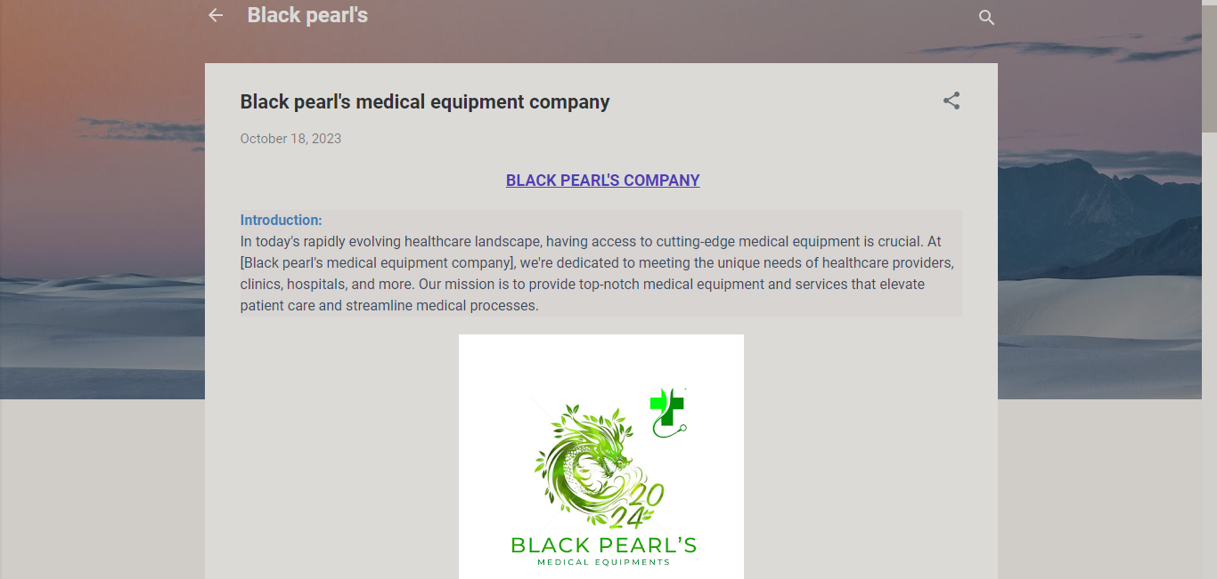

Wordpress URL:
https://blackpearlsmedicalequipments0.wordpress.com/2023/10/19/black-pearls-company/
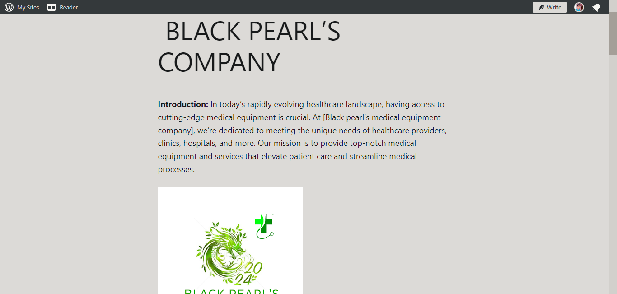
2.Create a New Facebook Business Page and Post One Social Media Poster for your brand.
https://facebook.com/blackpearlsmed
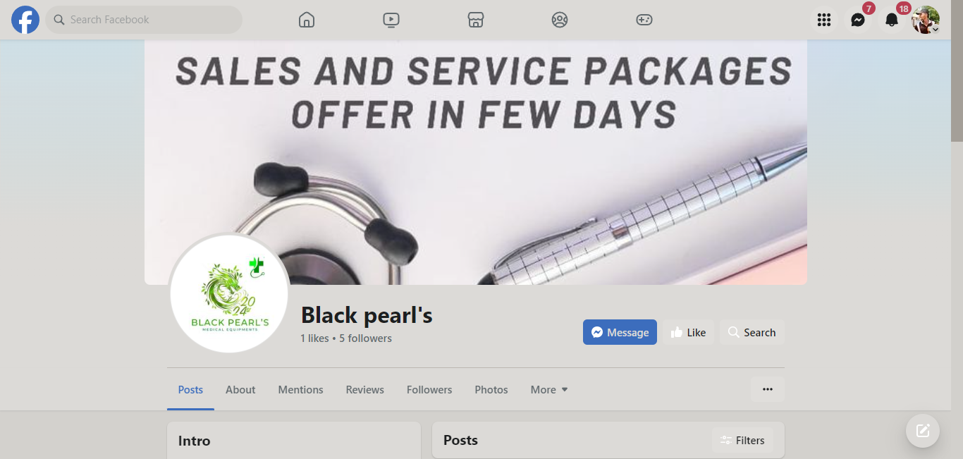

3.Create and design a social media advertisement poster using canva.

4. Create email news letter design using Canva or mail chimp.
